**ITEC 630**

**Final Exam**

**The Final is due by midnight (11:59 PM) Sunday, 12-3-2017**.

This is an open-book individual exam comprised of **5 questions.**

Guidelines:

* **Put your name in the exam**.
* You should submit your exam to your assignment folder in WebTycho in a MS-Word, MS-RTF, PDF or ASCII file. Please scan your file against viruses before submitting.
* Please keep the full text of the question as part of your answering sheet.
* Be as clear and objective as you can in all questions and be sure you are answering what is asked.
* **Justify all your numerical answers and answer all the questions using your own words. Show all your work, including how you found your answer** (this is very important and essential to have your answer graded appropriately!)**.**

**Make sure that you read, acknowledge, and follow the following rules**

Rules:

* This is an open-book exam but you are only allowed to use your textbook and information posted in our classroom. Please do not use any other sources that are not listed in our classroom. *For example, you can refer to our class lecture notes and all links posted in the lecture notes but you should not search the Web for information to solve exam questions.*
* **Note: Do not post multiple files. The exam should be posted in one file.**

**Acknowledge:**

**I, __ _____ acknowledge the above rules.**

*(Your name)*

**Problem I -** **(50 points)**

Consider a school advising system in which a faculty advisor can advise many students, each of whom can register for one or many courses. The following is an example of an un-normalized STUDENT table for three students.

**STUDENT**

|  |  |  |  |  |  |  |  |  |  |
| --- | --- | --- | --- | --- | --- | --- | --- | --- | --- |
| Student Number | Student Name | Total Credits | GPA | Advisor Number | Advisor Name | Course Number | Course Description | Course Credits | Grade |
| 1034 | Linda | 47 | 3.60 | 59 | Smith | CSC101 | Computer Science I | 4 | B |
|  |  |  |  |  |  | MKT211 | Marketing Management | 3 | A |
|  |  |  |  |  |  | ENG101 | English Composition | 3 | B |
|  |  |  |  |  |  | CHM111 | General Chemistry I | 4 | A |
|  |  |  |  |  |  | BUS101 | Introduction to Business | 2 | A |
| 3397 | Sam | 29 | 3.00 | 59 | Smith | ENG101 | English Composition | 3 | A |
|  |  |  |  |  |  | MKT211 | Marketing Management | 3 | B |
|  |  |  |  |  |  | CSC101 | Computer Science I | 4 | B |
| 4070 | Kelly | 14 | 3.20 | 23 | Jones | CSC101 | Computer Science I | 4 | B |
|  |  |  |  |  |  | CHM111 | General Chemistry I | 4 | A |
|  |  |  |  |  |  | ENG101 | English Composition | 3 | B |
|  |  |  |  |  |  | BUS101 | Introduction to Business | 2 | B |

Perform the normalization process to convert the above un-normalized table to:

1. First normal form (1NF).

2. Second normal form (2NF).

3. Third normal form (3NF).

Please show all your work. Please show each step along the way and identify primary keys, if any, in each table in each step.

**Problem II -** **(50 points)**

**Part A:** Your systems analysis team is close to completing a system for Friendly Feeds. Robert is quite confident that the programs that he has written for Friendly’s inventory system will perform as necessary, because they are similar to programs he has done before. Your team has been very busy and would ideally like to begin full systems testing as soon as possible.

Two of your junior team members have proposed the following:

1. Skip desk checking of the programs (because similar programs were checked in other installations; Robert has agreed). (10 points)
2. Do link testing with large amounts of data to prove that the system will work. (10 points)
3. Do full systems testing with large amounts of live data to show that the system is working. (10 points)

*Respond to each of the three steps in their proposed test schedule. Use a paragraph to explain your response.*

**Part B**: Mr. Frank Fickle, the owner of Fickle Office Supplies Company, had contacted you for your advices on a new information system installed recently at his company to help improving his company inventory tasks. He told you that the team that came to install the system does not have any evaluation mechanism and he also mentioned to you that some of his employees had complained about the new system’s inputs and outputs. Since he wants to obtain the inventory result of this quarter, he would like to delay or skip the new system evaluation and use the new system for inventory right away. Given the above conditions, he would like to have your advices on his decision and on the evaluation of his new system.

1. In a paragraph, explain to Mr. Fickle about problems that can occur when a system is not evaluated systematically? (10 points)
2. Devise a checklist or form that helps Mr. Fickle’s employees evaluate the utilities of the new information system. Suggest a second way to evaluate the information system, if any. Please be specific and explain your answers. (10 points)

**Problem III -** **(50 points)**

Cindy Brown owns a homeopathic medicine company called Faithhealers. She sells vitamins and other relatively nonperishable products for those who want choices regarding alternative medicine. Cindy is developing a new system that would require her staff to be retrained.

1. Given the information in Figure 3.EX3 (Kendall & Kendall, page 102), make a PERT diagram for her and identify the critical path. (24 points)

**Description Task Must Follow Time**

Interview Executives A None 6

Interview staff in orders fulfillment B None 3

Design input prototype C B 2

Design output protype D A,C 3

Write use cases E A,C 4

Record staff reactions to prototypes F D 2

Develop system G E,F 5

Write up training manual H B,G 3

Train staff working in order fulfillment I H 2

1. If Cherry could find away to save time on the “write use cases” phase, would it help? Why or why not (26 points)

**Problem IV-** **(50 points)**

The problem is that the orders are not easily placed to the European plant, which is compounded whenever demand for the products increases dramatically. The company is looking for a systems solution that will address the problem and the solution should stress collaboration, flexibility, adaptability, and access.

One of your systems analyst team members proposed the following simple network solution that is to create an intranet that links the U.S. distributors with the European headquarters.

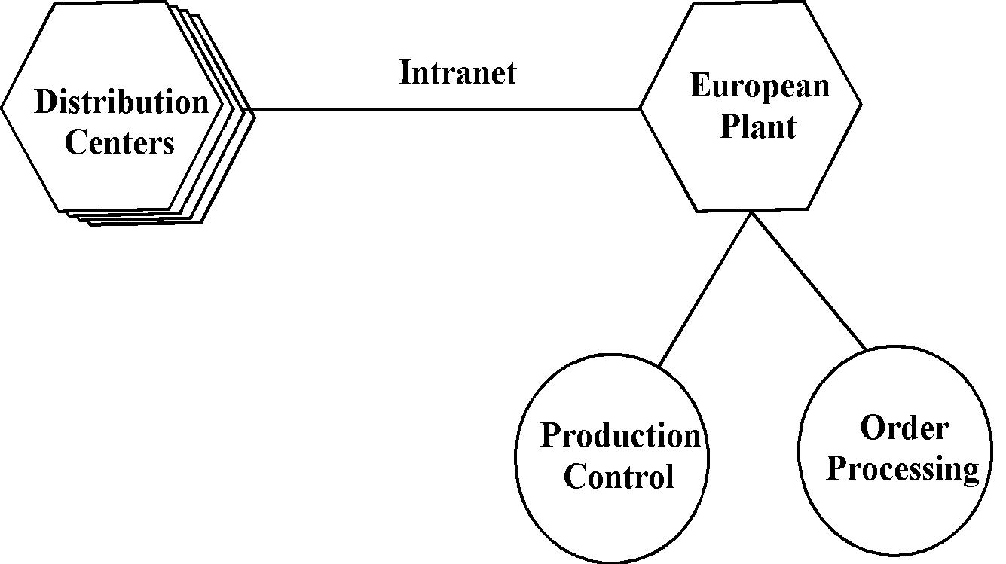

As a systems analyst, respond to this proposal by answering the following question:

**“Does this proposed network solve the problem mentioned in Consulting Opportunity 3.1?”**

If the answer is “Yes”, please explain the reasons why you support this proposal. Otherwise, explain the reasons why you disagree with the proposal and in case you are not completely agree with the solution, please offer some modifications to improve it.

**Problem V -** **(50 points)**

The United Health chain of hospitals has had a problem with its pharmacies missing medications. Management has hired you to design a centralized database for use by all hospital pharmacies. Here is the information that you gather:

* Patients are identified by an SSN, and their names, addresses, and ages must be recorded
* Doctors are identified by an SSN. For each doctor, the name. specialty, and years of experience must be recorded.
* Each hospital’s pharmacy is identified by name and has a phone number
* For each drug, the trade name and formula must be recorded. Each drug is sold by a given pharmaceutical company, and the trade name identifies a drug uniquely from among the products of that company. If a pharmaceutical company is deleted, you need not keep track of its products any longer.
* Each hospital’s pharmacy has a name, address, and phone number
* Every patient has a primary physician. Every doctor has at least one patient
* Each pharmacy sells several drugs and has a price for each. A drug could be sold at several pharmacies, and the price could vary from one pharmacy to another.
* Doctors prescribe drugs for patients, and a patient could obtain prescriptions from several doctors. Each prescription has a date and a quantity associated with it. You can assume that, if a doctor prescribes the same drug for the same patient more than once, only the last such prescription needs to be stored.
* Pharmaceutical companies have long-term contracts with individual hospital pharmacies. A pharmaceutical company can contract with several hospital pharmacies, and a hospital pharmacy can contract with several pharmaceutical companies. For each contract, you have to store a start date, an end date, and the text of the contract.
* Hospital pharmacies appoint a supervisor for each contract. There must always be a supervisor for each contract, but the contract supervisor can change over the lifetime of the contract.

1. Draw an ER diagram that captures the preceding information. Identify any constraints not captured by the ER diagram
2. How would your design change if each drug must be sold at a fixed price by all hospital pharmacies within the chain? (Requirement: Provide a narrative (text) explanation) (25pts.)
3. How would your design change if the design requirements change as follows: If a doctor prescribes the same drug for the same patient more than once, several such prescriptions may have to be stored? (Requirement: Provide a narrative (text) explanation) (25pts.)

**Note: Do not post multiple files. The exam should be posted in one file.**